**University of Petroleum and Energy Studies**

School of Computer Science

Department of Cybernetics



**Graphics & Animation Tools**

**LAB Assignment**

**(Session: 2020-2021)**

Course: B. Tech with Specialization in Open Source and Open Standards

Batch: 2017-2021

Semester: VIIth

**Submitted By: -**

Rahul Gupta

Roll No: R100217055

SAP ID: 500062765

**Submitted To: -**

Dr. Durgansh Sharma Assistant Professor

Department of Cybernetics

Task 1 :Design a phone in gimp

In this task we need to create a phone of our choice with the help of GIMP.

Steps to follow

1. Open GIMP and create a new file.
2. Using free select tool create a layout of phone and fill it with black colour.
3. Using free select tool create a bezel and nauge of phone (inner layout screen) fill it with white color.
4. Fill the path stroke with solid color.

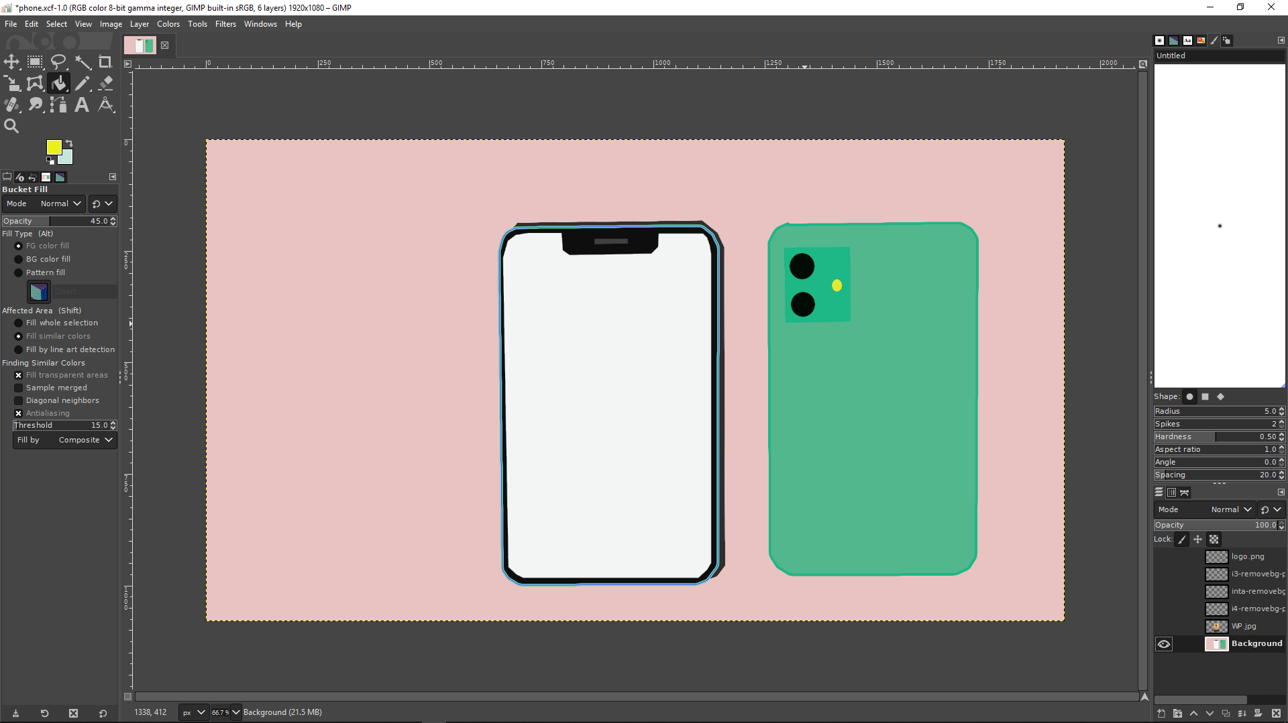

1. Import a image for wallpaper from computer using path to selection and delete the wallpaper outside phones inner screen.

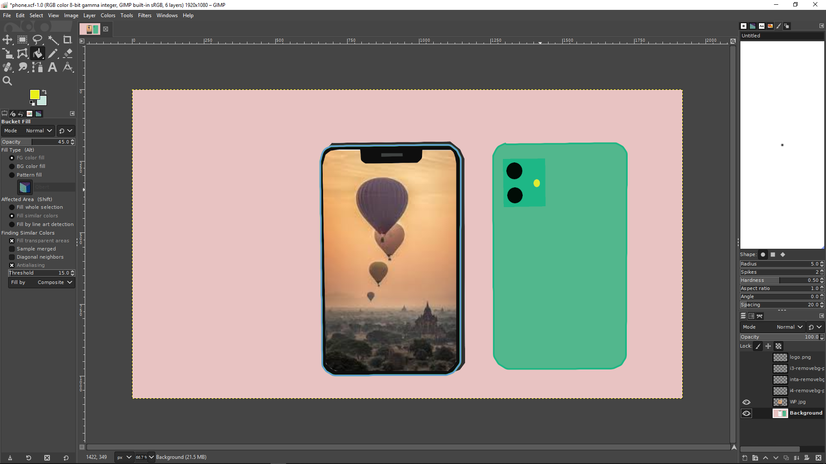

1. Add icons on the screen.
2. Now draw back of phone using free select and fill it with solid color
3. Create a rectangular box and fill it with dark solid color.
4. Import apple logo and place it to center at back.
5. Go to file and save it as your name .
6. Go to file and import it as .png.

**OUTPUT:**

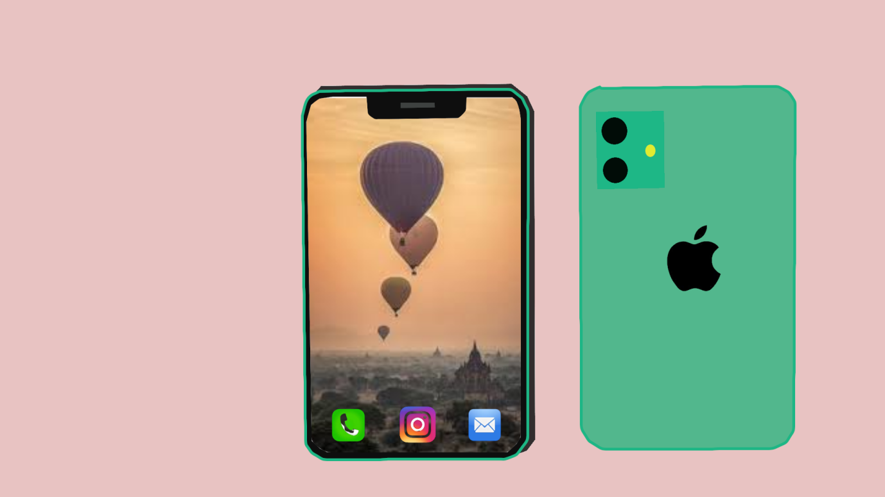

Task 2 :Design a 3-d fruits in blender

In this task we need to create a phone of our choice with the help of GIMP.

Steps to follow to create a 3D Hut using Blender

1. Create a new file and clear the interface.
2. Add mesh 3-d sphere.
3. Using G-key give the shape of sphere as apple.
4. Using select and G key push the down portion of sphere inside
5. Add modifier sub vision surface and make the edges smooth.
6. Using UV editing add and save as new image.
7. Add new material and import a image for texture.
8. Using image texturing give texture to image.
9. Now take a cube and using E,G key give it shpae of banana
10. Now add modifier sub vision surface and make the edges smooth.
11. Now using add material and fill the object with yellow color to mke it look like banana.
12. Save the file.

Output

